# Write data into file

# 1.Introduction

*3 most popular type: FileWriter, BufferedWriter, PrintWriter

*Difference: new line

FileWriter when write file must use character \n to get new line

BufferedWriter already written new line character

*Recommend: PrintWriter

Can use with UTF-8 code, and a lot of methods support

# 2.PrintWriter detail

2.1 (System.out) parameter

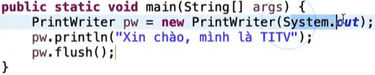

2.2 (“FileName”, “TypeCharacter”) parameter: Write data into file, use set UTF-8 character

